Python HackPack - by Raul

**Python Lists**

Counter Library

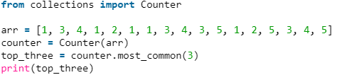

This will print the top 3 most common numbers in a list.

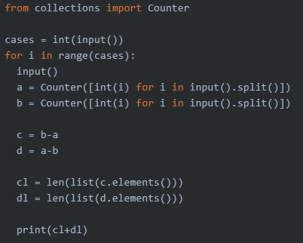

The Counter library is useful for comparing lists. In this case, I was able to “subtract” two lists.

Ex:

a = [1, 2, 3, 4, 5]

b = [1, 2, 3, 3, 5]

list((a-b).elements()) = [4]

list((b-a).elements()) = [3]

Heapq Library

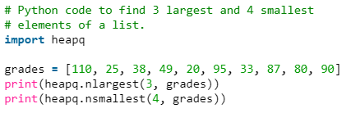

Heapq is useful for comparing array elements to eachother. These methods get the biggest 3 and smallest 4 items (respectively).

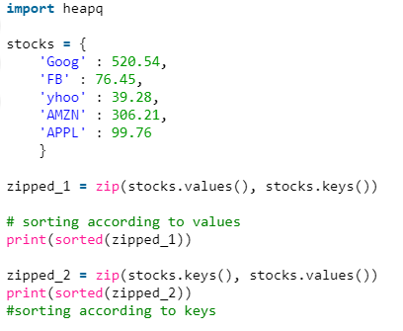

zip essentially “zips” together the keys and values into an array, and makes an array out of these arrays.

Datetime Library

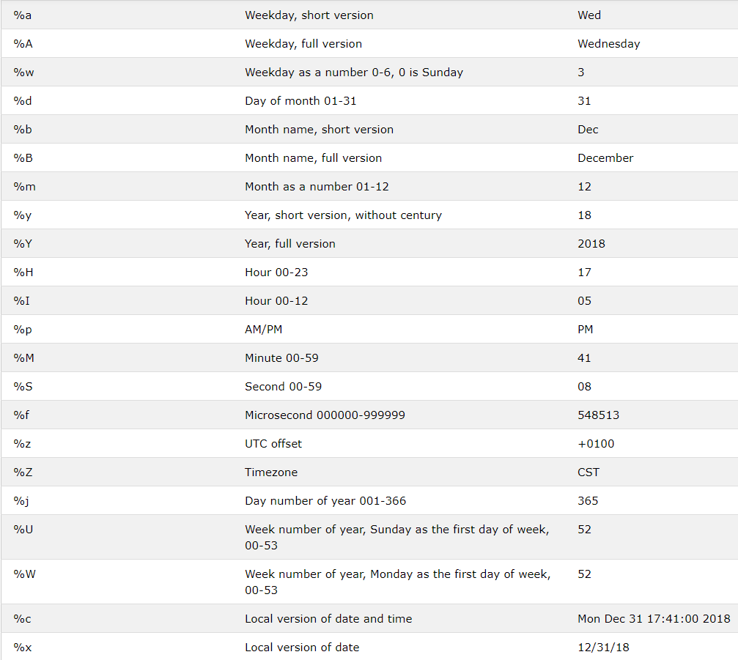

Mapping input to output

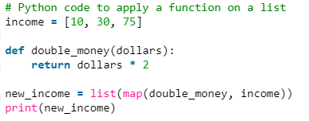

This will make an array with the input mapped to the output.

Built-In List Joining



Nested List => Single List

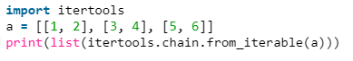

Permutations/Combinations

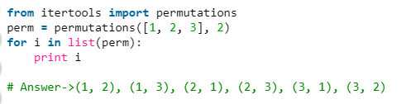

Pairing Same Indexed Elements



Ex: [(1,4), (2,5), (3,6)]

Standard List functions

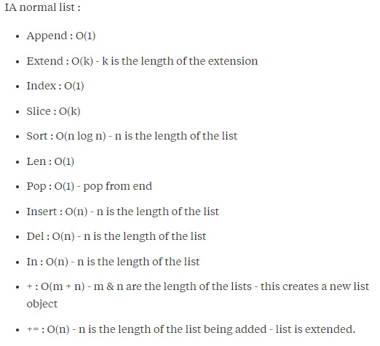

Convenient Input Methods

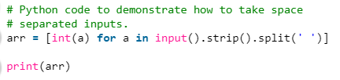

You can cast items as you iterate through a list.

Multiple Outputs

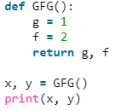

Sets and Dictionaries

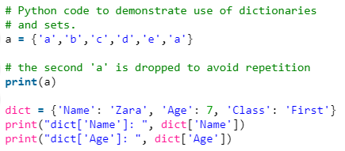

Convenient Swapping

